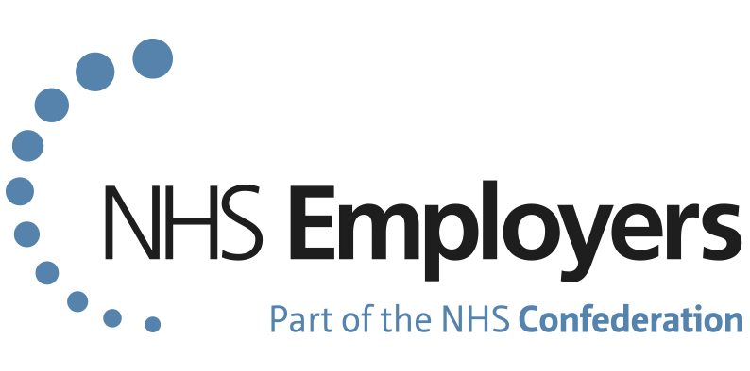
TOTAL REWARD STATEMENTS:
UPDATING YOUR LOCAL BENEFITS PAGE
EMPLOYER CHEKLIST

We encourage employers to continue to keep their local benefits page up to date and promote the full range of benefits offered locally.

Use this checklist to prepare and promote your local offers

- Review your current reward offering – is your current offer what employees want? For instance, do you have benefits to support health and wellbeing, security, finance and lifestyle?
- Make sure all the local benefits you offer are included – do you offer car lease schemes, childcare vouchers or a staff gym?
- Use NHSBSA’s guidance - update your local benefits page of the total reward statements.
- Highlight the advantages of each benefit – communicate to employees what you can offer them.
- Include the financial savings associated with each benefit – these are important to employees, for example tax savings from salary sacrifice schemes.
- Link to your employee intranet or other sources of information – provide links to information so employees can read more about your local offer.
- Update your employer and benefit provider contact details – make sure these contact details are up to date, so employees know where to go for more information.
- Use local branding – this helps to make the section look familiar for employees.
- Finally, make sure the information on the local benefits page is up to date – take a look at the information and check it is still relevant for your employees.
Further resources to support you
- Read more about the importance of offering local employee benefits on our reward strategy toolkit web pages.
- Use our handy communications guide to support your conversations with staff around reward.
- For step-by-step instructions on how to update your local benefits page, and to see a completed example, please visit the NHS Pensions website.

