**Health and wellbeing icons**

Health and wellbeing general



Mental wellbeing

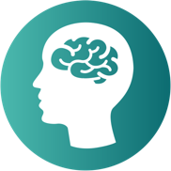

Physical wellbeing

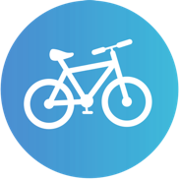

Financial wellbeing

Menopause

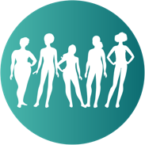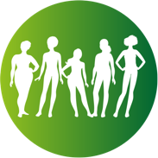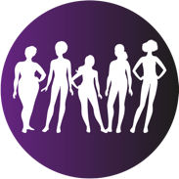

Family benefits & childcare

****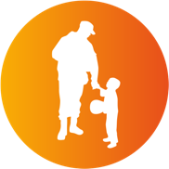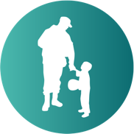

Travel

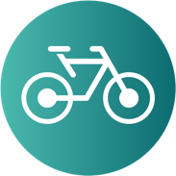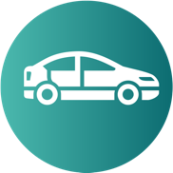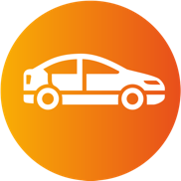****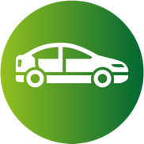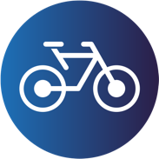

Calendar of events

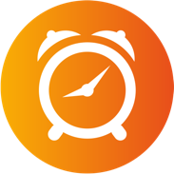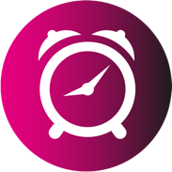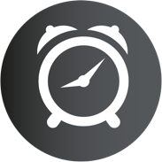

Discounts & vouchers

Recognition

Learning & development

