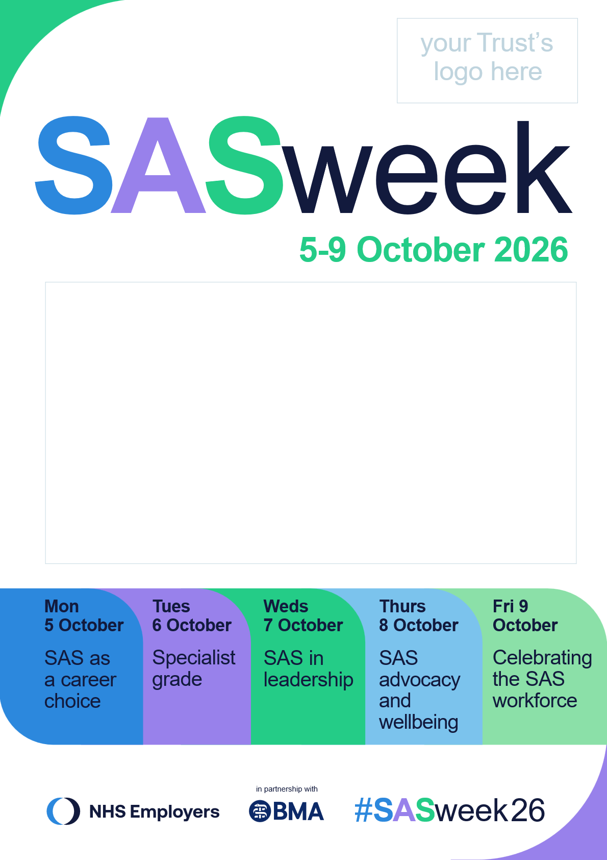
Space here for all your SAS week activity.

Add your organisation’s daily events and information here.

