**

|  |  |
| --- | --- |
| **REQUESTED BY** | |
| **Organisation name** |  |
| **Name**  **Email** |  |
| **DELIVERY INFORMATION** | |
| **Date of event** |  |
| **Event title** |  |
| **Destination address** | FAO:  Address 1:  Address 2:  Town:  County:  Postcode: |
| **Contact number at destination** |  |
| **RESOURCES AVAILABLE**  **(please see below for images etc)** | |
| * Pull up banner – English. We have three banners; how many do you need? * Pull up banner – Welsh. We have three banners; how many do you need? * English generic programme leaflets (pack of 30) – how many packs required? * Welsh generic programme leaflets (pack of 30) – how many packs required? * Table cloth. We have two table cloths; how many do you need? | |

***Terms and conditions***

*Resources will be delivered 24 hours prior to your event. Employers are asked to maintain the condition of the resources as found upon delivery and must report any damage immediately.*

*Resources are to be returned to NHS Employers within 72 hours of the event and associated costs will be met by the employer.*

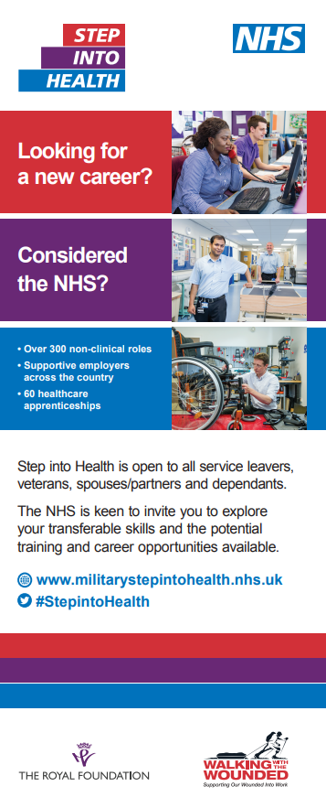**Pull up banner English**

Dimensions (in bag) – 85cm x 10cm x 10cm

Weight (in bag) – 3.33kgs

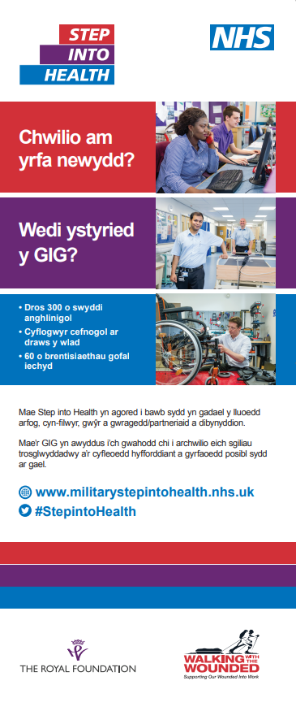**Pull up banner Welsh**

Dimensions (in bag) – 85cm x 10cm x 10cm

Weight (in bag) – 3.33kgs

**Generic programme leaflets – English A5**

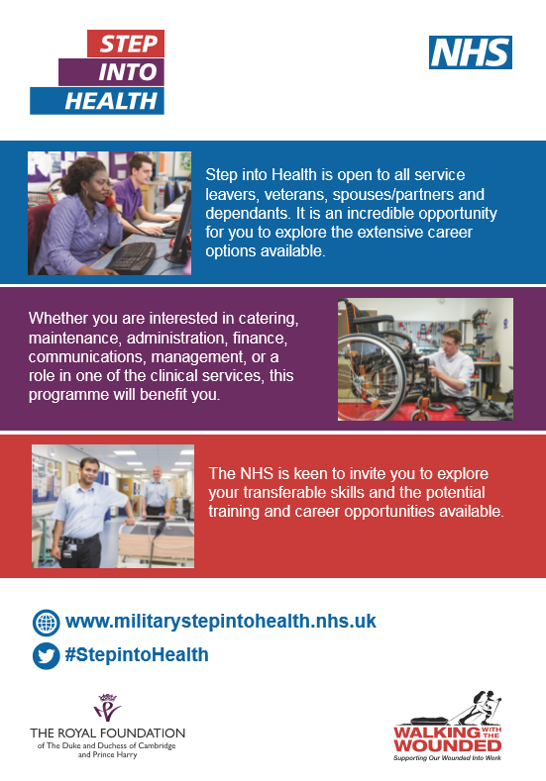

**Generic programme leaflets – Welsh A5**

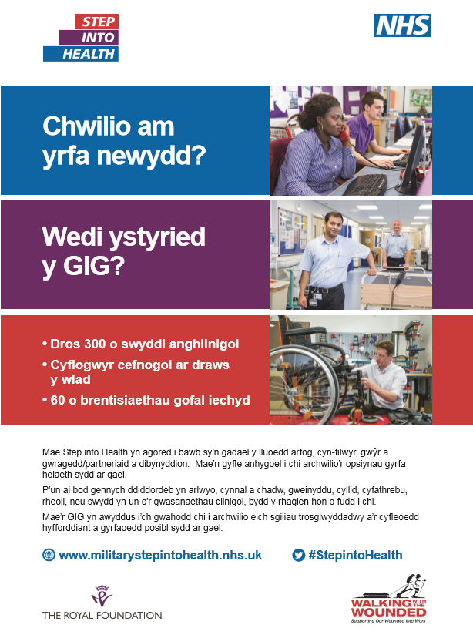

**Table cloth**

Dimensions: To fit table size 1830 x 770 x 720mm (fits a 6ft trestle table)

